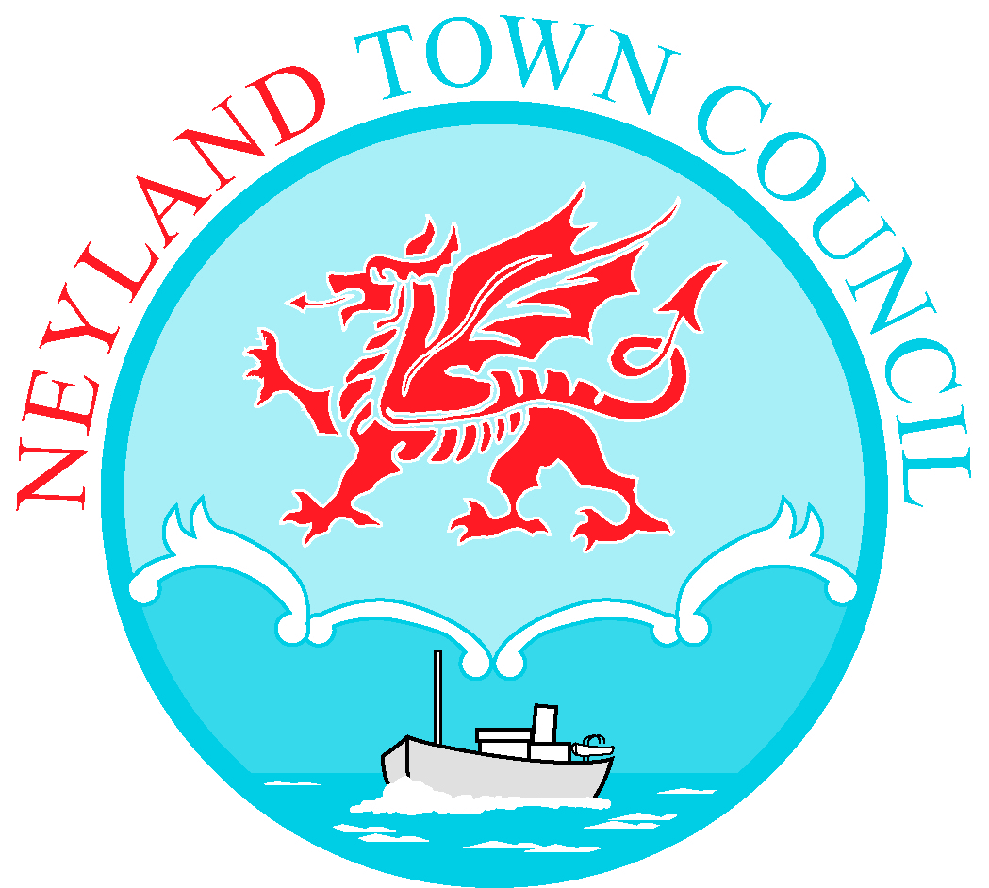

27th July 2022

TO: All Members of Neyland Town Council

Dear Councillor,
You are hereby summoned to attend a meeting of Neyland Town Council to be held on Tuesday 2nd August 2022 at 7.00pm at Neyland Community Hub. Please contact me for a link should you wish to attend virtually.

Yours sincerely

Vanessa Walker - Town Clerk/Financial Officer

AGENDA

- To appoint a Chair for this meeting.
- To receive apologies for absence.
- To welcome C Cllr. Josh Beynon to give update on the recent Pembrokeshire Pride event – document enclosed.
- To receive Declaration of Interest from Members regarding the business to be transacted.
- Representation by public (limited to 15 minutes)
- To approve the Minutes of the meeting held on 4th July 2022 – enclosed.
- To consider Matters Arising from the minutes of the meeting of 4th July 2022.
- To set up and confirm Committees.
- To discuss interview process for Co-option candidates.
- To discuss retirement and resignation of two doctors at the Neyland & Johnston Surgery – documents enclosed.
- To discuss request to support the Withybush Hospital campaign with a Model Motion – documents enclosed.
- To confirm land transfer ownership of field from Neyland Town Council to Neyland Athletics Club – documents enclosed.
- To agree a representative to attend the Neyland Community Hub Users Meeting on Wed. 17th August – documents enclosed.
- To consider quotations for Safer Surfacing safety matting for the Playpark – enclosed.
- Chair’s Announcements.
- To discuss suggestions for community benefit projects that could be paid for by the Wear Point turbine (JLEN): mixed age social club, disability friendly pathway through Playpark, suicide prevention project, slide in hotel gardens, Brunel Quay – documents enclosed.
- Financial information and transactions for approval and payment.
- Town Clerk’s report.
- Outstanding items from former Minutes not yet actioned – deferred to next meeting.
- Exchange of Information at discretion of Chair.
- Date of next meeting.

